CHAPTER ONE

INTRODUCTION

1.1 Background of the Study
Books remain one of the most essential resources in the learning process. However, with the rising cost of textbooks and the limited lifespan of their usage within academic sessions, many students struggle to afford the materials required for their courses and others have materials which they won’t use again. After a semester or academic year, countless used textbooks lie idle creating a cycle of waste and inefficiency in knowledge distribution.
The emergence of web technologies has revolutionized how people share and access resources. Take Peer-to-peer (P2P) systems as an example, it has provided opportunities for direct user interaction without intermediaries. Applying this concept, a book exchange platform can bridge the gap between students who have surplus textbooks and those who need them.
ReadCycle is designed to address this challenge by creating a web-based platform that allows students to exchange, lend, or sell used books within their academic community. The system promotes affordability, sustainability, and collaboration among students through a seamless online marketplace.

1.2 Statement of the Problem
Students in higher institutions frequently encounter difficulties in obtaining necessary textbooks due to:
- High cost of new books.
- Limited availability of specific course materials.
- Lack of a centralized system for locating and exchanging used books.
- Wastage of learning materials after a semester or academic session.
These challenges contribute to unnecessary spending, reduce access to educational materials, and discourage resource sharing. Therefore, there is a need for an efficient digital solution that enables students to connect and exchange books easily.

1.3 Aim and Objectives of the Study
Aim:
To design and develop a peer-to-peer web platform that enables students to exchange, lend, or sell used textbooks efficiently.
Specific Objectives:
The objectives of the system are to:
- Provide a user-friendly interface for students to list and browse available books.
- Enable search and filtering of books by title, author, or course code.
- Allow direct communication between buyers and sellers via an integrated messaging system.
- Facilitate book exchange or lending agreements between users.
- Promote sustainability by encouraging the reuse of educational materials.

1.4 Significance of the Study
The study is significant in several ways:
- It promotes cost savings among students by reducing the need to purchase new textbooks.
- It fosters academic collaboration by encouraging sharing of learning resources.
- It contributes to environmental sustainability through the reuse and recycling of educational materials.
- It serves as a technological learning project demonstrating practical application of web development, database management, and peer-to-peer systems.
- Institutions can adopt the system to enhance student engagement and resource accessibility.

1.5 Scope of the Study
This study focuses on developing a web-based peer-to-peer book exchange platform targeted at students within a university or college.
The system covers:
- User registration and authentication
- Book listing and management
- Search and filter features
- Direct messaging between users
It does not include online payment integration, delivery logistics, or large-scale commercial book trading (these may be considered in future upgrades).

1.6 Definition of Terms
- Peer-to-Peer (P2P): A network model where users interact directly without central intermediaries.
- Exchange: The act of giving and receiving items of similar value between users.
- Book Listing: The process of uploading book information to make it available to others.
- Marketplace: A virtual platform where users can buy, sell, or exchange goods.
- Sustainability: The practice of efficiently using resources to reduce waste and promote reuse.

CHAPTER TWO

LITERATURE REVIEW

2.1 Introduction
This chapter presents a comprehensive review of literature on book exchange platforms, peer-to-peer systems, and web-based marketplace technologies, with a particular focus on their application in educational contexts. Over the years, the sharing of books and learning resources has evolved from informal community exchanges to organized digital platforms, reflecting broader trends in technology adoption and collaborative consumption. Studies on peer-to-peer systems highlight the importance of trust, usability, and accessibility in facilitating resource sharing, while research on web-based marketplaces emphasizes the role of platform design, network effects, and user engagement in sustaining digital communities. By examining these frameworks, this chapter provides a conceptual foundation for understanding how ReadCycle operates within this ecosystem. Specifically, it situates ReadCycle at the intersection of technology and education, demonstrating how the platform can enhance access to learning materials, foster community collaboration, and promote sustainable knowledge exchange. Furthermore, this review identifies gaps in existing systems—such as limited user personalization, logistical constraints, and challenges in integrating feedback mechanisms—which inform the design principles and objectives of ReadCycle. By grounding the discussion in both technological innovation and educational theory, this chapter establishes the rationale for the development of a modern, user-centered book exchange platform that responds to the evolving needs of learners and educators.

2.2 Conceptual Review

2.2.1 Concept of Peer-to-Peer Systems
A peer-to-peer (P2P) system is a decentralized network model in which participants, or peers, share resources directly with one another, without depending on a central server. Unlike traditional client-server architectures, where a single server manages data and requests, each peer in a P2P network functions both as a client and a server, contributing resources while also consuming them. This structure allows for greater scalability, redundancy, and resilience, as the network does not rely on a single point of control.
In the context of ReadCycle, the P2P model plays a crucial role in facilitating the direct exchange of educational resources among students. By connecting users directly, the platform encourages collaboration and interaction, enabling students to lend, borrow, or share books in a more dynamic and efficient manner. Furthermore, the decentralized nature of P2P systems reduces dependency on institutional infrastructure, making ReadCycle accessible even in environments where centralized resources are limited. Studies on P2P networks emphasize their ability to promote community-driven sharing, foster trust among participants, and enhance the speed and availability of resource distribution—all of which are critical for the success of a student-centered book exchange platform..

2.2.2 Concept of Book Exchange
Book exchange is a system where individuals trade or lend books among Book exchange refers to a system in which individuals trade, lend, or share books with one another rather than purchasing new copies. This practice not only promotes the circulation of knowledge but also supports sustainability by reducing waste and minimizing the need for additional production of books. Traditionally, book exchanges relied on physical interactions, such as campus notice boards, student clubs, or community libraries, which limited participation to local networks and specific schedules.
With the advent of digital technologies, book exchange has increasingly moved online, enabling users to connect across wider communities and geographic boundaries. Online platforms facilitate real-time communication, tracking of transactions, and easier discovery of books, making the process more efficient and user-friendly. In the context of educational environments, digital book exchanges provide students with affordable access to learning resources while fostering collaborative learning and peer support. Platforms like ReadCycle leverage this concept by combining the sustainability and accessibility of book exchange with the convenience and interactivity of modern web-based systems, thereby enhancing the overall learning experience.

2.2.3 E-Marketplaces and Resource Sharing
An electronic marketplace (e-marketplace) is a web-based platform that connects buyers and sellers, facilitating the exchange of goods, services, or information. Prominent examples include platforms like Amazon, eBay, and Facebook Marketplace, which provide features such as search functions, user ratings, transaction tracking, and secure payment systems. While these platforms excel in efficiency and scalability, they are primarily commercial in nature and are not specifically designed to address the unique needs of academic or educational communities.
Student-focused book exchange platforms, such as ReadCycle, adapt the core principles of e-marketplaces—convenience, accessibility, and user engagement—to meet the objectives of knowledge sharing, affordability, and sustainability. By integrating features like peer-to-peer connectivity, resource tracking, and community interaction, such platforms enable students to exchange educational materials efficiently while fostering collaboration and responsible consumption. In this way, ReadCycle exemplifies how e-marketplace technologies can be repurposed to support academic environments, bridging the gap between modern digital infrastructure and the social goals of educational resource sharing.

2.3 Theoretical Framework

2.3.1 Disruptive Innovation Theory

Disruptive Innovation Theory, proposed by Clayton Christensen in 1997, explains how smaller, simpler, and more affordable innovations can gradually reshape or disrupt established markets. Unlike incremental innovations that improve existing products for current users, disruptive innovations initially target overlooked or underserved segments, offering solutions that may appear inferior at first but gradually gain traction and transform the market landscape.

ReadCycle exemplifies this theory by providing an accessible and cost-effective alternative to traditional bookstores and commercial textbook markets. By enabling students to exchange or borrow books directly from their peers, the platform addresses a key unmet need: affordable access to learning materials. In doing so, ReadCycle not only reduces the financial burden of purchasing textbooks but also fosters a culture of collaboration and sustainability within the academic community. This approach aligns with the core principles of disruptive innovation, demonstrating how digital platforms can create meaningful change by serving previously underserved users while challenging traditional educational resource models.

2.3.2 Collaborative Consumption Theory
Collaborative Consumption Theory, as described by Botsman and Rogers (2010), refers to a socio-economic system in which resources are shared, lent, bartered, or swapped among participants. This approach emphasizes access over ownership, enabling individuals to benefit from resources without the need to purchase or store them permanently. The theory highlights how trust, community engagement, and digital platforms can facilitate efficient sharing of goods and services, while also fostering sustainable consumption practices.
ReadCycle embodies the principles of collaborative consumption by providing students with a platform to access educational resources collectively rather than owning them individually. By enabling the lending, borrowing, and exchanging of books, ReadCycle encourages responsible resource use, reduces unnecessary spending, and builds a community-centered culture around knowledge sharing. Through this lens, the platform not only serves as a practical solution for affordable learning but also demonstrates how digital tools can transform traditional educational practices by prioritizing shared access and sustainability over individual accumulation.

2.4 Review of Related Systems
2.4.1 Amazon and eBay
Amazon and eBay are leading global e-commerce platforms that enable users to buy and sell products online, including used books. While they provide access to a wide range of educational materials, these platforms are primarily commercial, often charge listing fees, and lack features tailored to academic communities. They do not facilitate peer-to-peer interactions among students, nor do they support course-specific organization or institutional collaboration, which limits their relevance for student-focused book sharing.
2.4.2 BookMooch
BookMooch is an international book trading platform that allows users to give away books and earn points to request books from others. Although it encourages book sharing and community participation, its global focus makes it less practical for students seeking resources aligned with specific courses or local academic networks. Moreover, it lacks integration with academic structures, such as course codes or departmental categorization, which are critical for efficient student-to-student exchanges.
2.4.3 CampusBooks and TextSwap
CampusBooks offers textbook price comparison and purchase options, helping students find affordable books, while TextSwap (now defunct) allowed university students to swap books locally. These systems demonstrate the viability of student-centered book exchange; however, they show limitations in user engagement and technological features. Most lack modern functionalities such as real-time messaging, localized community networks, and seamless peer-to-peer coordination, which are essential for fostering interactive academic communities.
2.4.4 ReadCycle (Proposed System)
ReadCycle addresses the limitations of existing systems by providing a student-focused, peer-to-peer book exchange platform. Its key features include:
- Direct peer-to-peer exchanges within academic institutions.
- Real-time messaging and notifications for seamless coordination.
- Categorization of books by course code, department, and academic year.
- Promotion of eco-friendly practices by encouraging sharing instead of buying new copies.
By combining the convenience of digital platforms with the social and academic needs of students, ReadCycle offers a more targeted and effective approach to resource sharing.

2.5 Empirical Review
Several studies emphasize the value of digital platforms in enhancing access to educational resources and promoting collaboration:
- Adebayo (2019) found that web-based resource-sharing systems significantly improve students’ access to learning materials, particularly in contexts where textbooks are expensive or limited.
- Okafor & Nwosu (2021) highlighted that online peer-to-peer systems enhance collaboration among students while reducing duplication of educational resources.
- Bello (2022) demonstrated that integrating sustainability principles into educational technology initiatives fosters long-term benefits for both students and the environment.
These findings reinforce the relevance of ReadCycle as a practical innovation that not only improves access to learning materials but also promotes collaborative learning and sustainable practices.

2.6 Summary of Literature Review
The literature review reveals that while numerous online platforms exist for book trading and e-commerce, few are specifically designed to meet the unique needs of students in academic settings. Existing systems are often either overly commercial, too broad in scope, or lack social and collaborative features that encourage peer interaction and community engagement.
ReadCycle addresses these gaps by providing a dedicated, student-centered platform that emphasizes affordability, collaboration, and sustainability. By integrating peer-to-peer connectivity, course-specific organization, and eco-friendly practices, ReadCycle positions itself as a practical, socially responsible, and technologically innovative solution for modern educational resource sharing.

CHAPTER THREE

SYSTEM ANALYSIS AND DESIGN

3.1 Introduction
This chapter presents the analysis and design of the ReadCycle system, focusing on the requirements, architecture, and database structure that form the foundation for its development. The primary objective is to design a web-based platform that is user-friendly, efficient, and scalable, enabling students to exchange, lend, or sell books directly among themselves. By addressing the challenges associated with traditional methods of book sharing, ReadCycle aims to streamline access to educational resources, promote collaboration, and encourage sustainable practices within academic communities.

3.2 System Analysis
System analysis involves a careful examination of the current processes of book exchange among students, identifying their limitations, and proposing a structured system capable of resolving these challenges. It provides a clear understanding of the functional and non-functional requirements needed to develop an effective and reliable platform.
3.2.1 Existing System
In most tertiary institutions, students seeking textbooks from their peers rely on informal, manual methods such as word-of-mouth communication, social media groups, or physical notice boards. While these approaches allow some level of interaction, they present several challenges:
- Lack of centralized information: There is no single repository listing available books, making it difficult for students to know what is accessible.
- Time-consuming searches: Students often spend significant time locating specific titles or contacting multiple peers.
- No structured transaction records: Exchanges and communications are rarely documented, leading to misunderstandings or missed opportunities.
- Limited trust and accountability: Without formal mechanisms to verify availability or ownership, students may be hesitant to engage in exchanges.
Consequently, many textbooks remain unused, while other students are forced to purchase new copies, resulting in unnecessary expenditure and waste.
3.2.2 Problems Identified
The analysis of the existing manual system highlights several critical issues:
- Poor accessibility and lack of organization: Students cannot easily locate or filter available books according to course, department, or year.
- Inefficient communication: Interaction between buyers and sellers is slow, unstructured, and prone to delays.
- Inability to track availability and history: The current system does not allow students to monitor which books are available, who currently owns them, or past exchange records.
- Limited scalability: The manual approach is effective only within small networks or close student circles, making it unsuitable for larger academic communities.
These limitations underscore the need for a structured digital solution that leverages technology to enhance efficiency, transparency, and collaboration in student book exchanges. ReadCycle is designed to address these problems by creating a centralized, interactive, and peer-focused platform.

3.2.3 Proposed System
The proposed system, ReadCycle, is a web-based, peer-to-peer platform designed to provide students with a digital marketplace for exchanging, lending, or selling books efficiently. By leveraging automation, real-time communication, and centralized data management, ReadCycle addresses the key limitations of the existing manual system while enhancing accessibility, transparency, and collaboration among students.
Key improvements offered by the proposed system include:
- Online catalog: A searchable and organized database of available books, categorized by course, author, or title, allowing students to locate resources quickly.
- Direct messaging: Real-time communication between users for negotiations, inquiries, and coordination of exchanges.
- Secure login and verification: Authentication mechanisms to ensure trust and accountability within the student community.
- Real-time status updates: Instant notifications and updates on book availability, lending status, or pending transactions.
- Centralized data storage: A robust database system to store, manage, and retrieve user profiles, book listings, and communication history efficiently.
Through these features, ReadCycle transforms the traditional book exchange process into an intuitive, interactive, and student-centered experience, reducing wasted resources and fostering a collaborative academic environment.

3.3 System Design
System design involves transforming the requirements of ReadCycle into a structured blueprint that guides implementation. It defines how the system’s components—frontend, backend, and database—interact to deliver a functional, secure, and scalable application. System design ensures that the platform meets user needs while maintaining efficiency, reliability, and room for future expansion.

3.3.1 Objectives of System Design
The primary objectives of the ReadCycle system design are:
- Define database structure: Establish the logical organization of data to support efficient storage and retrieval.
- Specify data and control flow: Determine how information moves between components, ensuring smooth operation and communication.
- Ensure security and integrity: Protect user data, secure transactions, and maintain reliable system performance.
- Provide scalability: Design the system to accommodate growth in users, book listings, and new features without compromising performance.

3.3.2 System Architecture
ReadCycle is built on a three-tier architecture that separates the system into distinct layers, each responsible for specific functions:
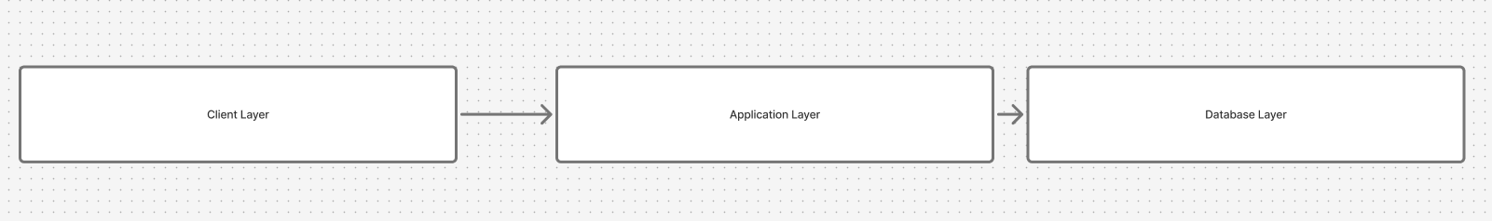
- Client Layer (Frontend):
  - Built with React and TailwindCSS, this layer provides an interactive interface where students can browse books, manage profiles, and communicate with peers via web browsers.
- Application Layer (Backend):
  - Implemented using Node.js and Express.js, this layer handles business logic, user requests, and communication between the frontend and database. It ensures proper processing of transactions, messaging, and data validation.
- Database Layer:
  - Managed using PostgreSQL, this layer stores persistent data including user accounts, book listings, transaction history, and messages. It ensures data integrity, security, and efficient retrieval.
This architecture promotes modularity, maintainability, and scalability, allowing ReadCycle to function reliably while accommodating future enhancements such as mobile support, recommendation systems, or analytics dashboards.
- .

3.3.3 System Flowchart (Text Description)
- User visits the ReadCycle homepage.
- If not logged in, user registers or logs in.
- Authenticated user can create, edit, or delete book listings.
- Another user searches or filters for a book.
- Upon finding a suitable listing, they can initiate a chat with the owner.
- Both users negotiate terms for sale, lending, or exchange.
- The transaction is completed, and book status is updated.

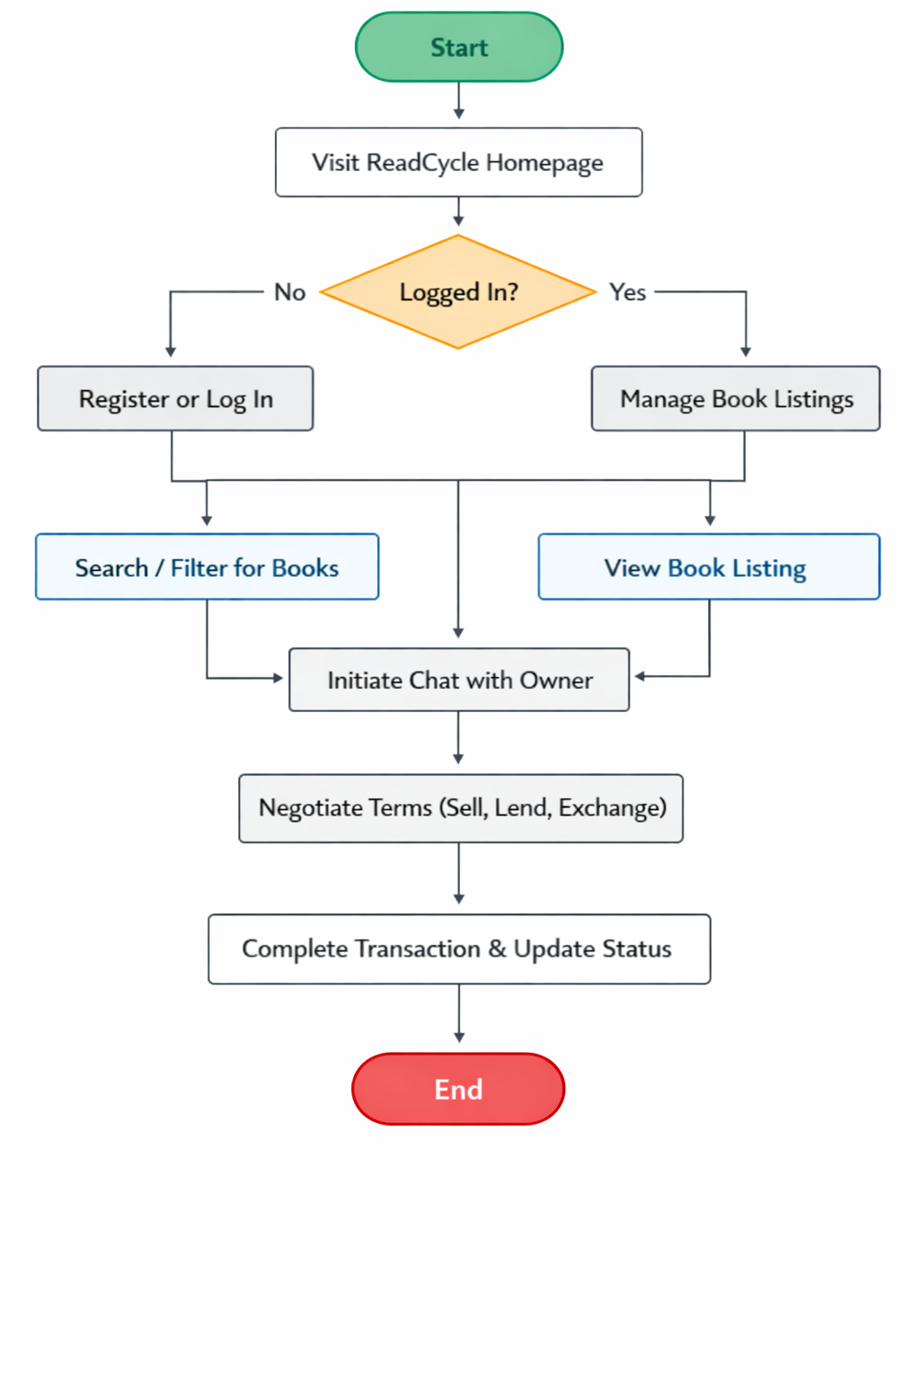

3.4 System Modules
Module | Description
User Management Module | Handles user registration, authentication, and profile management.
Book Management Module | Allows users to add, update, and delete book listings.
Messaging Module | Facilitates direct communication between users using real-time chat.
Exchange Module | Manages exchange transactions and tracks their status.

3.5 Database Design

3.5.1 Introduction

The database design for ReadCycle establishes the logical structure for efficiently storing, organizing, and retrieving data. A well-structured database ensures data integrity, minimizes redundancy, and supports all critical operations of the platform, including user management, book listings, searching, filtering, and messaging.

The design adopts a relational model, where data is organized into well-normalized tables connected through foreign keys to maintain referential integrity. This approach ensures that relationships between users, books, and transactions are clearly defined and that the system can handle concurrent operations without inconsistencies. A robust database design is essential for maintaining system performance, supporting real-time updates, and enabling future enhancements such as ratings, reviews, or payment features.

3.5.2 Database Design Objectives
TThe main objectives of the ReadCycle database design are:
- User Information Management:
  - Store detailed information about each user, including profile data, authentication credentials, and verification status.
- Book Listing Management:
  - Maintain comprehensive records of all book listings, including ownership, availability status, course code, and other relevant attributes.
- Messaging Records:
  - Record direct messages exchanged between users to support negotiation, coordination, and traceability of transactions.
- Search and Filtering Support:
  - Enable efficient search and filtering of books based on title, author, course, or department to enhance user experience.
- Flexibility for Future Enhancements:
  - Ensure the database structure can accommodate additional features such as reviews, ratings, payment integration, or advanced analytics without major restructuring.
This design ensures that the ReadCycle system is reliable, scalable, and capable of supporting a dynamic, peer-to-peer book exchange platform while maintaining data accuracy and security.

3.5.3 Entity–Relationship (ER) Diagram Overview
The ReadCycle system relies on a relational database in PostgreSQL. The main tables and their purposes are described below:
- Users Table (users)
  - Stores information about registered students, including profile details, university, major, contact info, and authentication data.
  - Supports account verification and password recovery features.
- Books Table (books)
  - Stores details of each book, including title, author, owner, course code, condition, listing type (swap, sale, rent), status, location, and optional cover image.
  - Tracks which user owns the book and facilitates peer-to-peer transactions.
- Conversations Table (conversations)
  - Represents messaging threads between users.
  - Can be a group conversation or one-to-one chat.
- Messages Table (messages)
  - Stores messages exchanged within a conversation.
  - Tracks the sender, content, status (sent, delivered, read), and timestamps.
- Conversation Participants Table (conversation_participants)
  - Maintains the list of users in each conversation.
  - Includes admin status and last seen timestamp.
- Notifications Table (notifications)
  - Tracks alerts for users, including type, title, body, priority, and read status.
  - Can handle individual notifications or platform-wide announcements.
- Indexes
  - Optimized for fast searches on key columns such as user_id, conversation_id, sender_id, and book_owner.

Relationships Between Tables
- Users ↔ Books: One-to-many relationship; a user can own multiple books.
- Users ↔ Messages: One-to-many for both sent and received messages.
- Users ↔ Conversations: One-to-many; a user can participate in multiple conversations.
- Books ↔ Exchange (conceptual): Each book can be involved in multiple exchanges over time.
This database structure ensures data integrity, efficient queries, and scalability for a peer-to-peer educational book exchange platform.

3.5.4 Table Structure

1. users
Stores all registered users’ information.
Field | Type | Description
user_id | UUID (PK) | Unique identifier for each user
full_name | VARCHAR(225) | User’s full name
email | VARCHAR(100) | Unique email address
avatar | TEXT | Profile image URL
is_online | BOOLEAN | Indicates if the user is active
university | VARCHAR(225) | User’s institution
major | VARCHAR(50) | Field of study
phone_number | VARCHAR(15) | Contact number
bio | VARCHAR(225) | Short profile description
password_hash | VARCHAR(225) | Encrypted password
isVerified | BOOLEAN | Email verification status
forget_password_token | VARCHAR(225) | Password reset token
forget_password_token_expires_at | TIMESTAMP | Token expiry time
verification_token | VARCHAR(20) | Email verification token
verification_token_expires_at | TIMESTAMP | Expiry for verification
created_at | TIMESTAMP | Account creation date
updated_at | TIMESTAMP | Last update time

2. books
Stores details of books uploaded by users.
Field | Type | Description
book_id | UUID (PK) | Unique book identifier
book_title | VARCHAR(100) | Title of the book
book_author | VARCHAR(100) | Author’s name
book_owner | UUID (FK) | User who listed the book
book_for | VARCHAR(20) | Purpose: sale, swap, or rent
book_to | UUID (FK) | User receiving the book
book_price | DECIMAL | Selling price
book_location | VARCHAR(220) | Book’s location
book_condition | VARCHAR(220) | Physical state of the book
book_description | VARCHAR(225) | Short details
book_course | VARCHAR(225) | Related course
book_cover | VARCHAR(225) | Image URL
book_swap_with | VARCHAR(225) | Preferred swap book
book_rental_period | VARCHAR(225) | Rental duration
book_status | VARCHAR | active, sold, swap, rented
created_at | TIMESTAMP | Listing date
updated_at | TIMESTAMP | Last update

3. conversation
Field | Type | Description
conversation_id | UUID (PK) | Unique conversation ID
is_group | BOOLEAN | Indicates group or private chat
group_name | VARCHAR(100) | Name of group chat
created_by | UUID (FK) | Creator of the conversation
last_message_id | UUID (FK) | Most recent message
created_at | TIMESTAMP | Start date
updated_at | TIMESTAMP | Last activity

4. conversation Participants
Field | Type | Description
conversation_id | UUID (FK) | Chat reference
user_id | UUID (FK) | Participant
is_admin | BOOLEAN | Admin role in group
last_seen_at | TIMESTAMP | Last activity
PRIMARY KEY | (conversation_id, user_id) | Unique pairing

5. messages
Handles direct communication between users.
Field | Type | Description
message_id | UUID (PK) | Unique message ID
conversation_id | UUID (FK) | Related conversation
sender_id | UUID (FK) | Sender
body | TEXT | Message content
status | VARCHAR(20) | sent, delivered, read
created_at | TIMESTAMP | Time sent
updated_at | TIMESTAMP | Last edit

6. Notifications Table
Field | Type | Description
notification_id | UUID (PK) | Unique notification
user_id | UUID (FK) | Recipient
type | VARCHAR(40) | Notification category
title | VARCHAR(100) | Heading
priority | VARCHAR(10) | Urgency level
action_performed | VARCHAR(150) | Triggered action
body | TEXT | Notification message
is_read | BOOLEAN | Read status
for_all | BOOLEAN | Broadcast flag
created_at | TIMESTAMP | Created time
updated_at | TIMESTAMP | Last update

3.5.5 Database Relationships
- One-to-Many: One user can list multiple books.
- Many-to-Many (via Exchange): Two users can exchange books.
- One-to-One (optional): Each exchange links two book records uniquely.
- One-to-Many: Each user can send many messages.

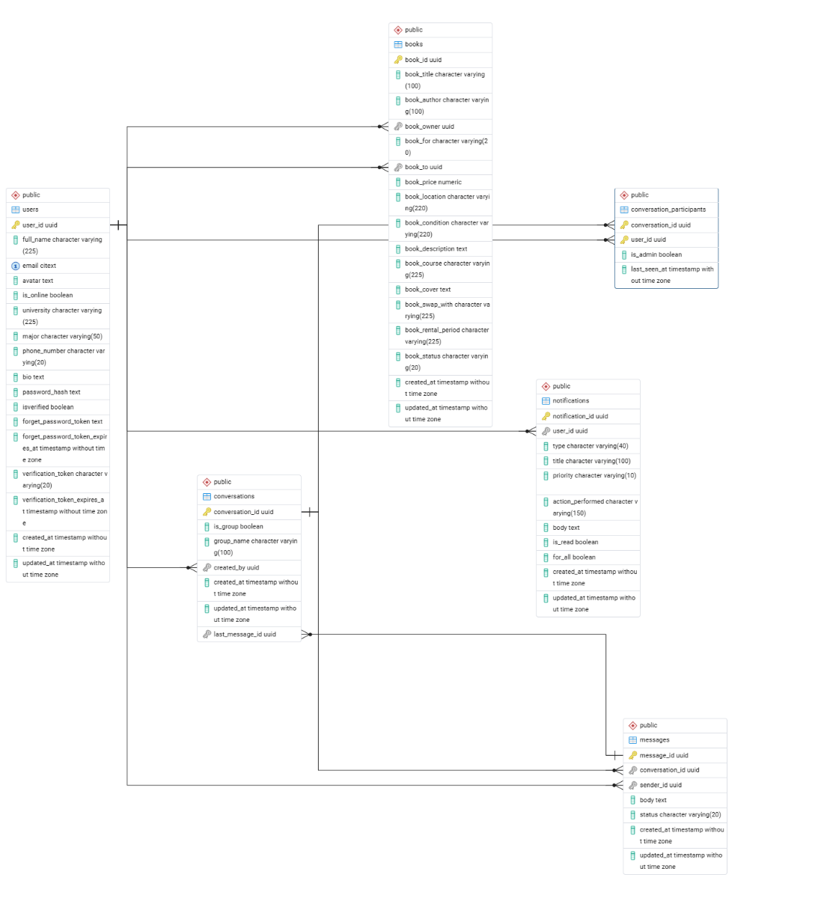

3.5.6 Normalization
The database is designed up to Third Normal Form (3NF):
- Each table has a primary key.
- No partial dependencies (non-key fields depend fully on PK).
- No transitive dependencies — data stored in the most relevant table.
This ensures minimal redundancy, easy maintenance, and optimized performance.
33.6 System Interface Design

3.6.1 User Interface (UI)
The ReadCycle system interface is designed to be simple, intuitive, and user-friendly, ensuring a smooth experience for students. The main interface components include:
- Home Page: Displays featured and recent book listings, enabling students to quickly browse available resources.
- Login/Register Page: Provides secure authentication for new and returning users.
- Dashboard: Presents the user’s profile, book listings, and messages in a centralized view.
- Book Details Page: Shows comprehensive information about a specific book, including title, author, condition, course code, and owner details.
- Chat Interface: Allows direct peer-to-peer communication for negotiations, lending arrangements, or exchanges.
The UI is structured to reduce cognitive load, guide users naturally through tasks, and encourage interaction with the platform.

3.6.2 Design Principles
The design of ReadCycle follows key principles to enhance usability and accessibility:
- Simplicity and Clarity: Minimalistic design to reduce distractions and improve navigation.
- Consistency: Uniform layout, colors, and typography aligned with the ReadCycle theme.
- Responsiveness: Optimized for use on desktops, tablets, and mobile devices.
- Accessibility: Ensures that all users, including those with disabilities, can navigate and interact with the platform effectively.
These principles ensure that users can efficiently access, list, and exchange books while maintaining a positive and engaging experience.

3.7 Security Considerations
Security is a critical aspect of ReadCycle to protect user data, transactions, and communications. Key measures include:
- Password Security: Passwords are securely hashed using bcrypt to prevent unauthorized access.
- Authentication and Session Management: JWT tokens are used for secure authentication and session control.
- Input Validation and Sanitization: All user inputs are validated and sanitized to prevent SQL injection and cross-site scripting (XSS) attacks.
- Secure Connections: All data transmitted between users and the server is encrypted via HTTPS, ensuring confidentiality and integrity.
These measures collectively safeguard the system against common security threats while maintaining usability.

3.8 Summary
This chapter provided a comprehensive analysis and design of the ReadCycle system. It examined the limitations of the existing manual book exchange process and proposed a robust, web-based alternative. The chapter presented:
- The system architecture and three-tier design (frontend, backend, and database).
- Database structure and relationships between users, books, messages, and notifications.
- User interface components and design principles focused on simplicity, consistency, responsiveness, and accessibility.
- Security measures to protect data, ensure authentication, and prevent attacks.
Overall, the design ensures that ReadCycle is secure, scalable, and user-friendly, providing a strong foundation for system development, implementation, and testing in the subsequent chapters.

CHAPTER FOUR

SYSTEM IMPLEMENTATION AND TESTING

4.1 Introduction
This chapter presents the implementation and testing of the ReadCycle system. It explains how the system was developed in line with the design specifications discussed in Chapter Three. The chapter describes the development environment, tools, and technologies used in building the system, as well as the implementation of the various system modules. Additionally, it outlines the testing procedures carried out to ensure that the system operates correctly, efficiently, and securely. The activities discussed in this chapter demonstrate how the proposed system design was transformed into a functional and reliable web-based application.

4.2 Development Environment
The development environment refers to the combination of hardware and software resources used in the design, development, implementation, and testing of the ReadCycle platform. These resources provide the necessary tools and infrastructure required to build, run, and evaluate the system efficiently.

4.2.1 Hardware Requirements
The system was developed and tested using the following hardware specifications:
- Computer system with at least:
  - Intel Core i5 processor or higher
  - 8GB RAM
  - 256GB storage
- Internet connectivity for testing real-time communication features
These specifications were sufficient to support frontend development, backend services, and database operations.

4.2.2 Software Requirements
The following software tools and technologies were used in the implementation of ReadCycle:
- Operating System: Windows 10
- Frontend Technologies:
  - React.js
  - Tailwind CSS
- Backend Technologies:
  - Node.js
  - Express.js
- Database:
  - PostgreSQL
- Development Tools:
  - Visual Studio Code
  - Postman (API testing)
  - Git and GitHub (version control)
- Web Browser:
  - Google Chrome
These tools were selected for their reliability, scalability, and suitability for modern web application development.

4.3 System Implementation
The ReadCycle system was implemented using a modular approach, where each system component was designed, developed, and tested independently before being integrated into the complete system. This approach improves system maintainability, simplifies debugging, and ensures that individual modules function correctly before full deployment.

4.3.1 User Management Module Implementation
The User Management Module is responsible for handling user registration, authentication, and profile management within the ReadCycle platform. It ensures that only authorized users can access and interact with the system.
Key functionalities implemented include:
- User registration with email and password
- Secure login using JWT-based authentication
- Password hashing using bcrypt
- Profile creation and update
- Email verification and password recovery support
This module ensures that only authenticated and verified users can access core system features, thereby enhancing system security, user accountability, and data integrity.

4.3.2 Book Management Module Implementation
The Book Management Module is responsible for handling all operations related to book listings within the ReadCycle platform. This module enables users to create, manage, and monitor their book entries efficiently.
The following features were implemented in this module:
- Adding new book listings with detailed information such as book title, author, related course, condition, listing type (sale, rent, or swap), price (if applicable), and location.
- Editing and deleting existing listings, allowing users to update book information or remove listings when no longer available.
- Viewing book details, where users can access comprehensive information about a selected book before initiating communication with the owner.
- Automatic status updates, where the system dynamically updates the book status (available, sold, rented, or swapped) based on transaction activities.
All book-related data is securely stored in the PostgreSQL relational database and is linked to the respective user through a foreign key relationship. This ensures proper ownership tracking, data integrity, and efficient retrieval of listings

4.3.3 Search and Filter Implementation
To enhance usability and improve user experience, a search and filtering mechanism was implemented within the ReadCycle system. This feature enables users to quickly locate relevant textbooks without browsing through all available listings manually.
The search functionality allows users to retrieve books based on the following criteria:
- Book title
- Author name
- Course code
- Department
The filtering mechanism refines search results by narrowing listings according to selected categories, ensuring that only relevant books are displayed. This significantly reduces search time, improves efficiency, and enhances overall system responsiveness.
By integrating optimized database queries and indexed fields, the system ensures fast and accurate retrieval of results even as the number of book listings increases.

4.3.4 Messaging Module Implementation
The messaging module enables direct peer-to-peer communication.
Implemented features include:
- One-to-one chat between users
- Conversation creation and management
- Message delivery and read status tracking
- Notification alerts for new messages
This module facilitates negotiation and coordination between students during book exchanges.

4.3.5 Notification Module Implementation
The notification system keeps users informed of important activities.
Notifications are triggered for:
- New messages
- Book status updates
- System announcements
Each notification is stored in the database and marked as read or unread, improving user engagement and responsiveness.
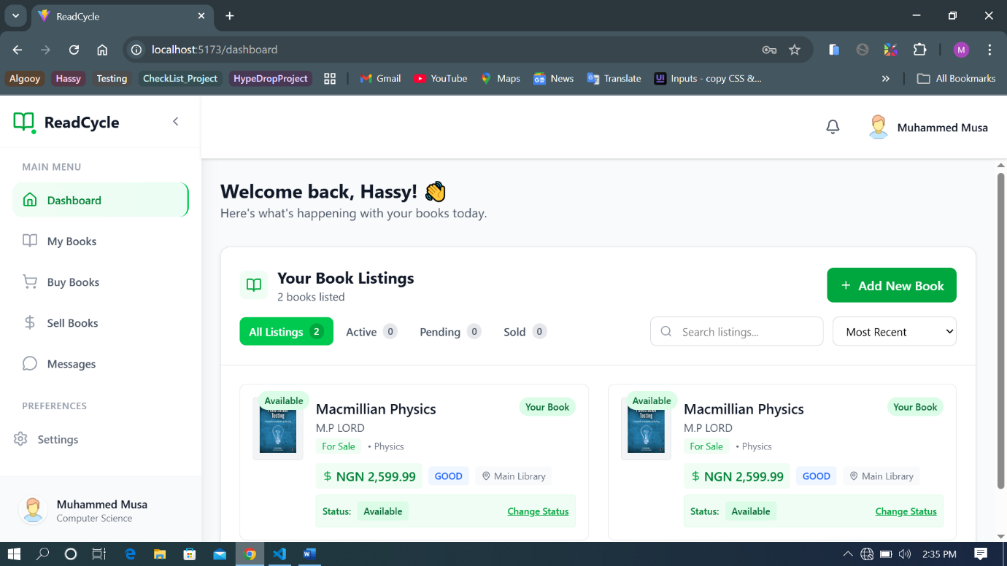
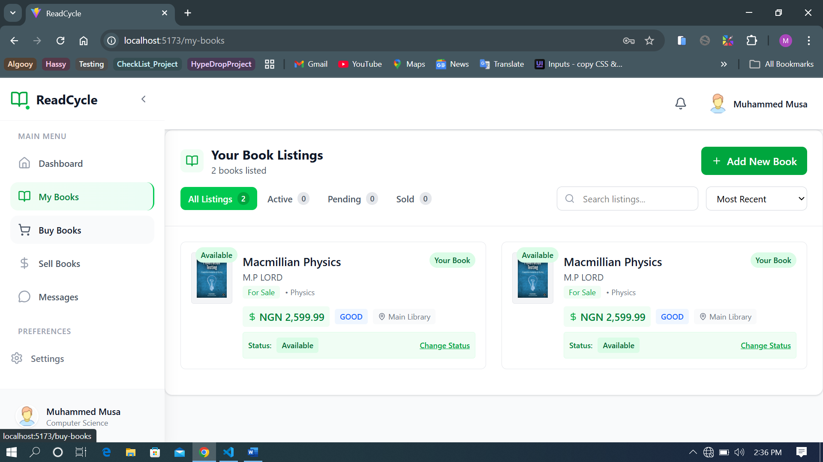
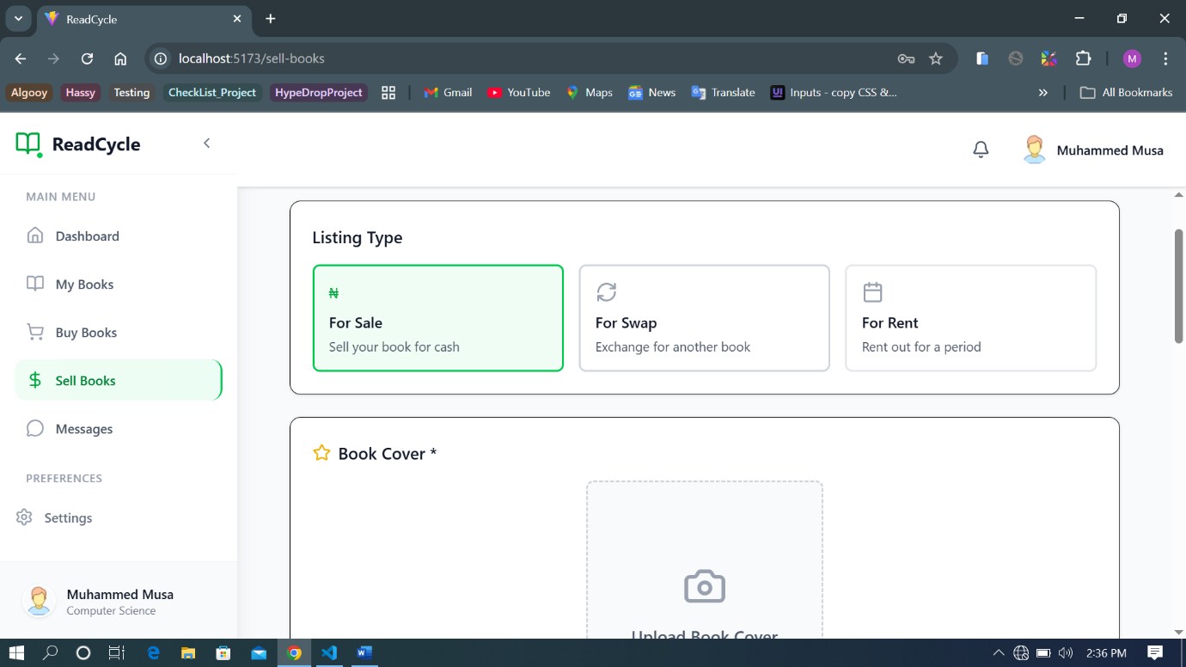
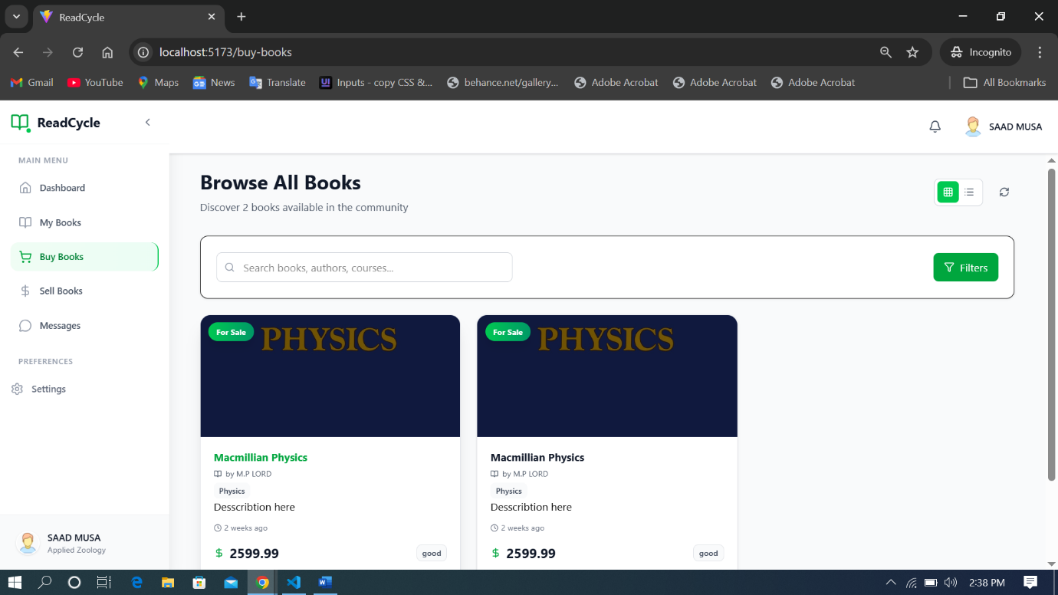
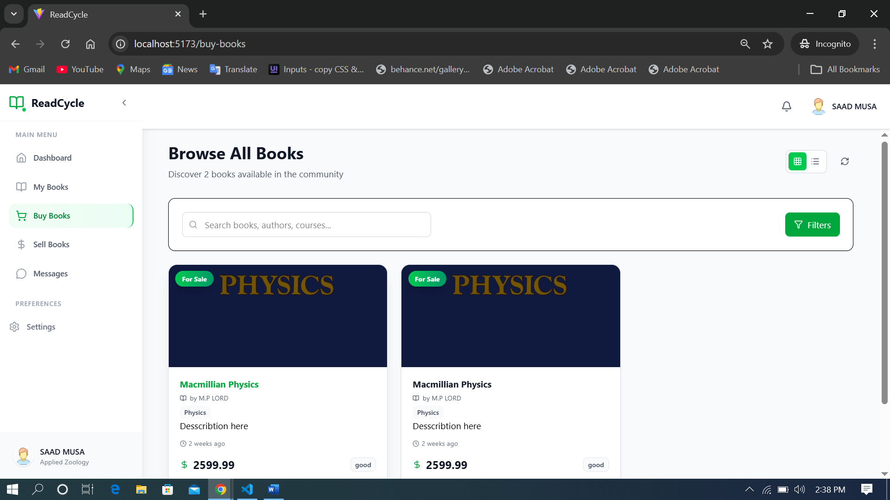

4.4 System Testing
System testing was conducted to verify that all components of ReadCycle function as expected and meet system requirements.

4.4.1 Testing Approach
The following testing techniques were applied:
- Unit Testing: Individual modules were tested independently.
- Integration Testing: Interactions between modules were tested to ensure smooth data flow.
- Functional Testing: System features were tested against specified requirements.
- User Acceptance Testing (UAT): Simulated student users tested the system for usability and functionality.

4.4.2 Test Cases and Results
Test Case | Description | Expected Result | Status
User Registration | Register new user | Account created successfully | Passed
User Login | Authenticate user | Successful login | Passed
Add Book | Create book listing | Book saved to database | Passed
Search Book | Search by title/course | Relevant books displayed | Passed
Messaging | Send message | Message delivered | Passed
Notification | Trigger alert | Notification received | Passed
All major system functionalities performed as expected without critical errors.

4.5 System Performance Evaluation
The system demonstrated good performance during testing:
- Fast response time for book searches and messaging
- Stable database operations with multiple users
- Secure authentication and data handling
- Responsive UI across different screen sizes
The modular architecture also allows for easy future enhancements.

4.6 Challenges Encountered
During implementation, the following challenges were encountered:
- Managing real-time message synchronization
- Ensuring secure authentication and session handling
- Database relationship complexity between users, books, and conversations
These challenges were addressed through proper error handling, modular coding, and thorough testing.

4.7 Summary
This chapter discussed the implementation and testing of the ReadCycle system. It detailed the development environment, tools used, system module implementation, and testing procedures. The results show that ReadCycle meets its design objectives by providing a secure, efficient, and user-friendly peer-to-peer book exchange platform for students.

